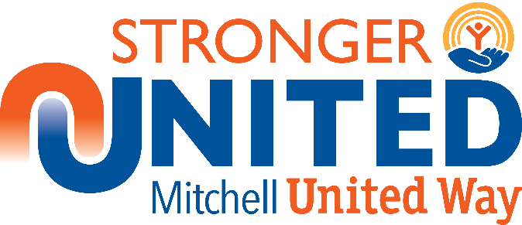
2019 Day of Caring
August 14, 2019
Project Description Form

Individual/Agency __________
Project__________________________________________________________________________________
Title___________________________________________________________________________________
Phone No. _Email: ____________________________
Contact Person at project site

Please check the category that describes your project:
  - Minor Maintenance ❑ Indoor Cleaning ❑ Yard Work ❑ Painting
  - Construction ❑ Landscaping ❑ Other (Specify)

Give a description of the job to be done:

Number of volunteers needed: Maximum Minimum

Supplies/Equipment: Each agency/nonprofit organization or individual wanting this work done is responsible for securing the needed supplies, equipment and tools. Volunteers may be asked to bring certain supplies (such as paintbrush, hammer) if needed.

Do you carry liability insurance which would cover the volunteers? ❑ Yes ❑ No
Please mail or e-mail this form by Friday, July 26, 2019, to:
Dave Stevens
Mitchell United Way
PO Box 729
Mitchell, SD 57301
Phone: 605.996.3915
E-mail: stevens@mitchellunitedway.org

