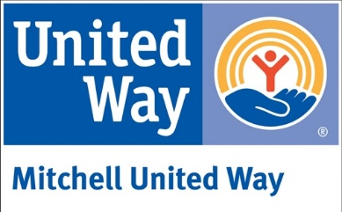
Mitchell United Way
PO Box 729 ⏐ Mitchell, SD 57301
stevens@mitchellunitedway.org

Grant Award Follow-Up Report

Evaluation is an integral part of the grant process that is necessary for our records and will assist us in project assessment and future grant awards. As a part of your grant award the Mitchell United Way COVID-19 Relief Board requires you to return this document to Mitchell United Way within six months from the grant date. Failure to return this follow-up report could affect future application for funds.

CONTACT INFORMATION:

Grant Date: Grant Amount:

Organization Name:

Address: City: State: Zip Code:

Organization Contact: Email: Phone:

NARRATIVE:

Describe how this grant supported any costs associated with your organization’s programs, affected by COVID-19. Examples: supplies/equipment purchased; staff involvement; distribution costs; and any other pertinent information considered useful to know.

Describe how this grant helped meet your organizations goals and what difference it made to your targeted population. List any unanticipated benefits or challenges encountered with your project.

Attach any pictures, event marketing or documentation of the grant-supported activities.

